Recurrence Relation (Contd..)

**Recursion Tree Method:**

1. Recursion Tree Method is a pictorial representation of an iteration method which is in the form of a tree where at each level nodes are expanded.

2. In general, we consider the second term in recurrence as root.

3. It is useful when the divide & Conquer algorithm is used.

4. It is sometimes difficult to come up with a good guess. In Recursion tree, each root and child represents the cost of a single subproblem.

5. We sum the costs within each of the levels of the tree to obtain a set of pre-level costs and then sum all pre-level costs to determine the total cost of all levels of the recursion.

6. A Recursion Tree is best used to generate a good guess, which can be verified by the Substitution Method.

**Example 1**

 Consider T (n) = 2T + n2

We have to obtain the asymptotic bound using recursion tree method.

**Solution:** The Recursion tree for the above recurrence is

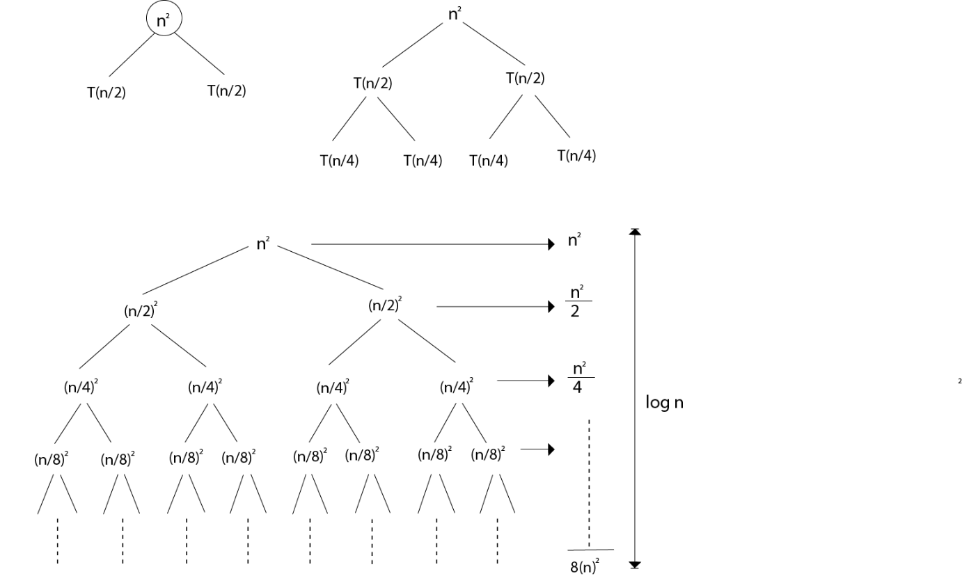

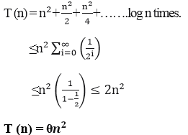

Top of Form

**Example 2:** Consider the following recurrence

T (n) = 4TDAA Recurrence Relation +n

Obtain the asymptotic bound using recursion tree method.

**Solution:** The recursion trees for the above recurrence

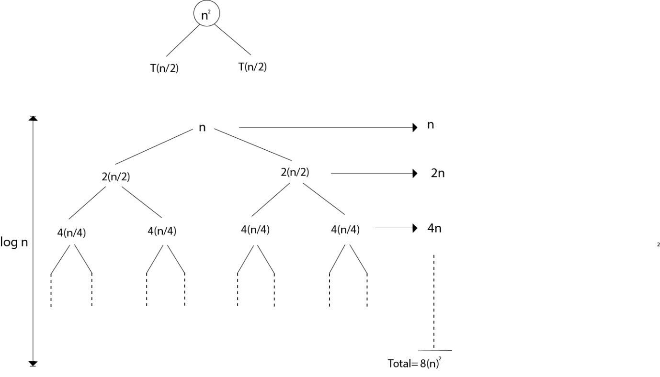

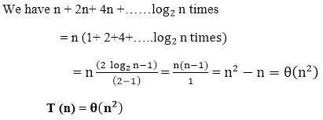

Bottom of Form

Top of Form

**Example 3:** Consider the following recurrence

DAA Recursion Tree Method

Obtain the asymptotic bound using recursion tree method.

**Solution:** The given Recurrence has the following recursion tree

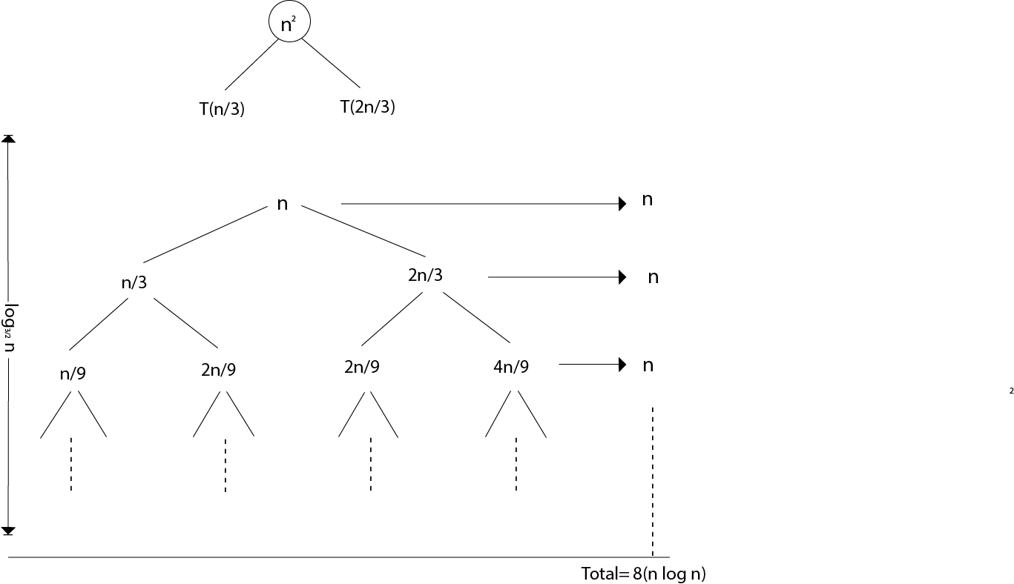

When we add the values across the levels of the recursion trees, we get a value of n for every level. The longest path from the root to leaf is

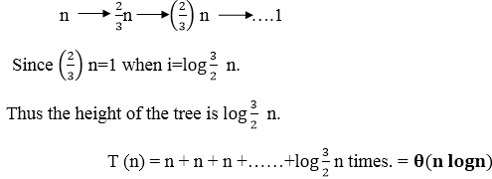

Bottom of Form

Top of Form

**RELEVANT READING MATERIAL AND REFERENCES:**

**Source Notes:**

1. <https://www.javatpoint.com/daa-recurrence-relation>

**Lecture Video:**

1. <https://www.youtube.com/watch?v=lBFiDGkR9-M>
2. <https://youtu.be/1K9ebQJosvo>
3. <https://www.youtube.com/watch?v=4p1WqREIJq8&list=RDQMC3YAwRZTuRo&start_radio=1>

**Online Notes:**

1. <http://vssut.ac.in/lecture_notes/lecture1428551222.pdf>

**Text Book Reading:**

1. Cormen, Leiserson, Rivest, Stein, “*Introduction to Algorithms*”, Prentice Hall of India, 3rd edition 2012. problem, Graph coloring.

**In addition: PPT can be also be given.**